SIMATS ENGINEERING
ASSESSMENT TOOL 1 NAME :M. Keerhi
COURSE NAME: Database Management Systems REGNO:192525243
COURSE CODE: CSA05
Q1
Given a set of relations and sample data, write SQL queries to retrieve specific information using joins and subqueries, and explain the logic used. Bloom’s Level: BL3 – Apply
1.CREATE STUDENT TABLE
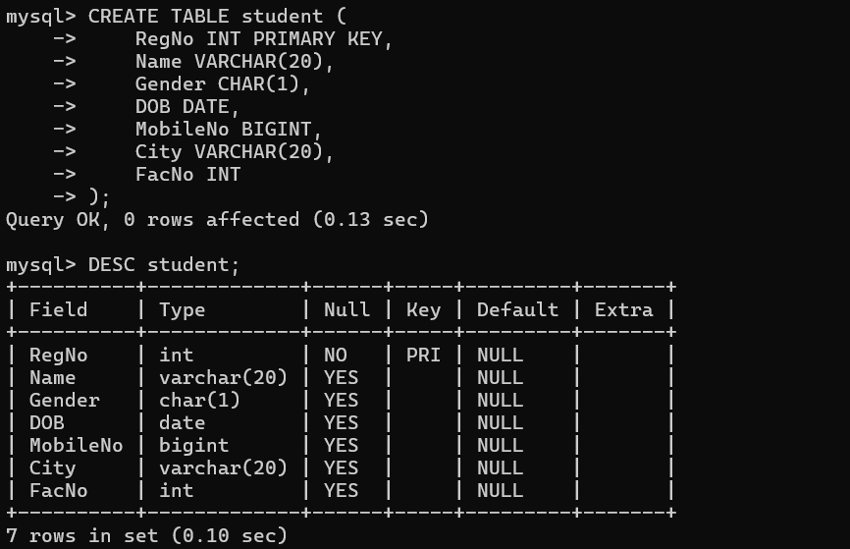
2CREATE DEPARTMENT TABLE
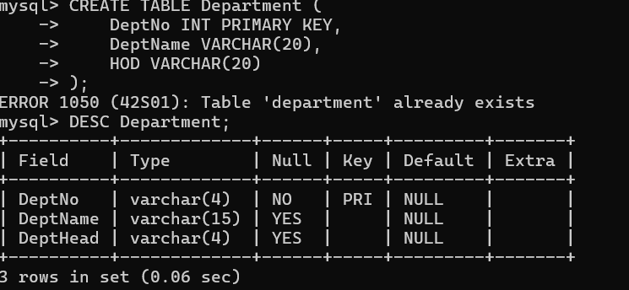

3. Insert Sample Data
Department
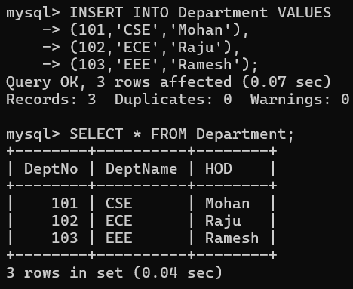
Student
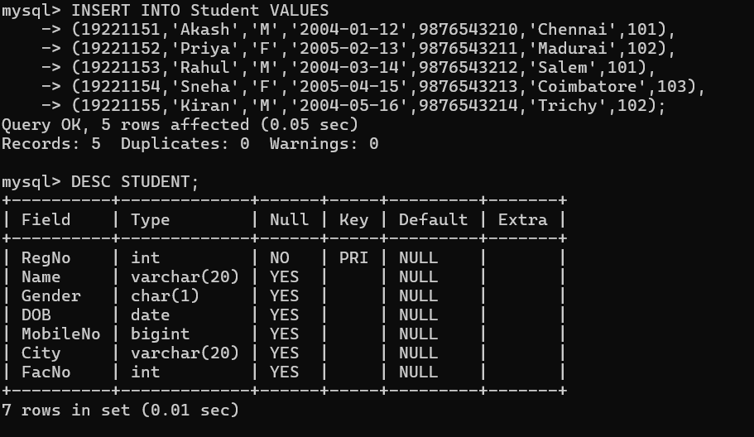

JOIN Queries
1. Display Student Name and Department Name
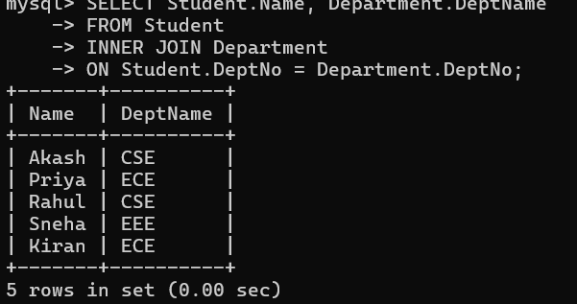
Q2 Using relational algebra, formulate expressions to solve complex queries such as retrieving records that satisfy multiple conditions across relations.Bloom’s Level: BL4 – Analyse
ANS:
Relations
STUDENT(RegNo, Name, Gender, Dept_No)
DEPARTMENT(DeptNo, DeptName, HOD)

Query 1
Retrieve the names of students who belong to the CSE department.
Relational Algebra:
πName(σDeptName='CSE'(STUDENT ⨝ STUDENT.DeptNo = DEPARTMENT.DeptNo DEPARTMENT))

Query 2
Retrieve the names of female students in the CSE department.
Relational Algebra:
πName(σGender='F' ∧ DeptName='CSE'
(STUDENT ⨝ STUDENT.DeptNo = DEPARTMENT.DeptNo DEPARTMENT))

Query 3
Retrieve the names of students whose HOD is 'Mohan'.
Relational Algebra:
πName(σHOD='Mohan'
(STUDENT ⨝ STUDENT.DeptNo = DEPARTMENT.DeptNo DEPARTMENT))

Query 4
Retrieve the names and department names of all students.
Relational Algebra:
πName,DeptName
(STUDENT ⨝ STUDENT.DeptNo = DEPARTMENT.DeptNo DEPARTMENT)

Query 5
Retrieve the department names having female students.
Relational Algebra:
πDeptName
(σGender='F'
(STUDENT ⨝ STUDENT.DeptNo = DEPARTMENT.DeptNo DEPARTMENT))

Query 6
Retrieve the names of students who belong to the ECE department.
Relational Algebra:
πName
(σDeptName='ECE'
(STUDENT ⨝ STUDENT.DeptNo = DEPARTMENT.DeptNo DEPARTMENT))

Operators Used
Symbol | Meaning
σ | Selection (filters rows based on a condition)
π | Projection (selects required columns)
⨝ | Join (combines two relations using a common attribute)
∧ | Logical AND (multiple conditions)
Explanation
- Selection (σ) is used to filter records based on one or more conditions.
- Projection (π) is used to retrieve only the required attributes.
- Join (⨝) combines the STUDENT and DEPARTMENT relations using the common attribute DeptNo.

Bottom of Form

Q3
relational schema and construct appropriate SQL queries for data retrieval and updates. Bloom’s Level: BL6 – Create
- Create Student Table

2. Insert Sample Data
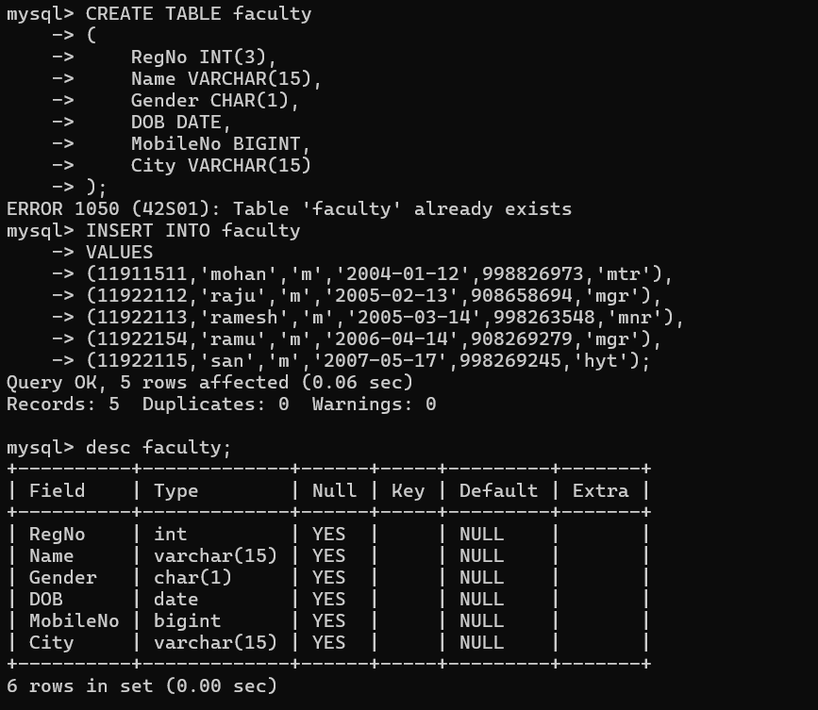
3. Display All Students
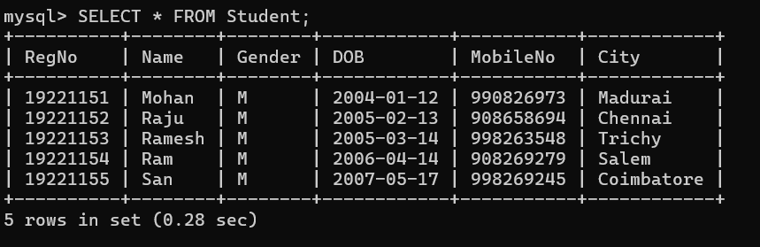
4. Display students from Chennai.
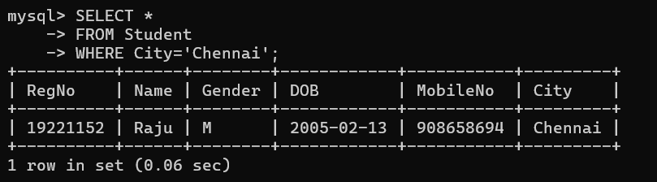

Q4.Analyse a given SQL query with nested subqueries and predict its output, explaining each step of execution.Bloom’s Level: BL4 – Analyze

Nested Subquery
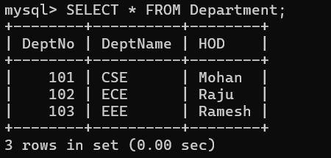

Q5 Compare different SQL approaches (joins vs subqueries) for solving the same problem and evaluate their efficiency.Bloom’s Level: BL5 – Evaluate
ANS;
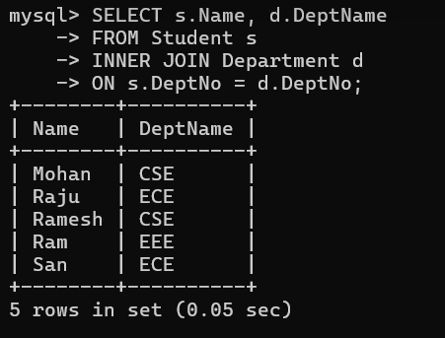

Q6 .Design and implement views for a database system to provide restricted data access, and justify their use for security and abstraction.Bloom’s Level: BL6 – Create
ANS;
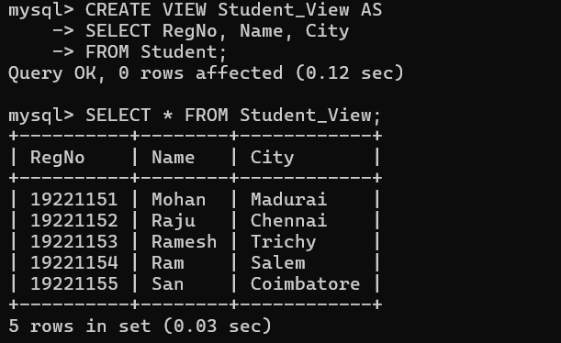

Q7 Given a database schema, write relational algebra expressions and convert them into equivalent SQL queries, analyzing differences in representation.Bloom’s Level: BL4 – Analyze
ANS; Given Database Schema
Student

Student_ID Student_Name Dept_ID Marks

Department Dept_ID
Dept_Name
Example 1: Students in the CSE Department
Relational Algebra
πStudent_Name,Dept_Name(σDept_Name=′CSE′(Student⋈Department
Equivalent SQL
SQL
SELECT Student.Student_Name, Department.Dept_Name
FROM Student
JOIN Department
ON Student.Dept_ID = Department.Dept_ID
WHERE Department.Dept_Name = 'CSE';

Analysis
Relational Algebra: Uses σ (Selection), ⋈ (Join), and π (Projection).
SQL: Uses WHERE, JOIN, and SELECT.
Both return the same result, but SQL is more user-friendly and executable.
Example 2: Students Scoring More Than 80
Relational Algebra
πStudent_Name,Marks(σMarks>80(Student))
Equivalent SQL
Example 3: Average Marks Department-wise
Relational Algebra (Extended)
γDept_ID, AVG(Marks)→Avg_Marks(Student)

Equivalent SQL :
SELECT Dept_ID,
AVG(Marks) AS Avg_Marks
FROM Student
GROUP BY Dept_ID;
Analysis
• Extended RA uses the γ (Grouping) operator.
• SQL uses GROUP BY with aggregate function
SQL is easier to read and directly supported by DBMSs.
Example 4: Student Names with Department Names
Relational Algebra
πStudent_Name,Dept_Name(Student⋈Department)

Equivalent SQL:
SELECT Student.Student_Name,
Department.Dept_Name
FROM Student
JOIN Department
ON Student.Dept_ID = Department.Dept_ID;
Analysis
• RA uses the join operator ⋈.
• SQL uses the JOIN ... ON clause.
• Both produce the same output.
Comparison: Relational Algebra vs SQL

Relational Algebra SQL
Procedural query language Declarative query language
Uses symbols like σ, π, ⋈ Uses keywords like SELECT, FROM, WHERE
Describes the sequence of operations Describes the required result
Mainly used for query design and optimization Used to interact with real databases
Theoretical foundation Practical implementation
Database Schema
STUDENT(RegNo, Name, Gender, DOB, MobileNo, City)

Query 1
Display the names of students from Chennai.
Relational Algebra
πName(σCity='Chennai'(STUDENT))
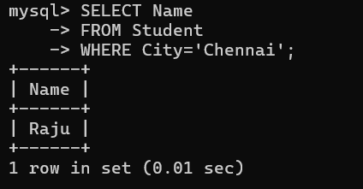
Query 2
Display the registration number and name of male students.
Relational Algebra
πRegNo,Name(σGender='M'(STUDENT))
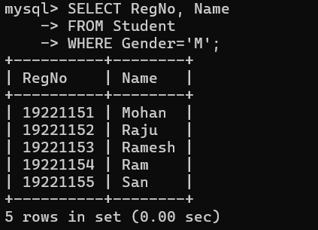
Query 3
Display all students born after 01-01-2005.
Relational Algebra
σDOB>'2005-01-01'(STUDENT)
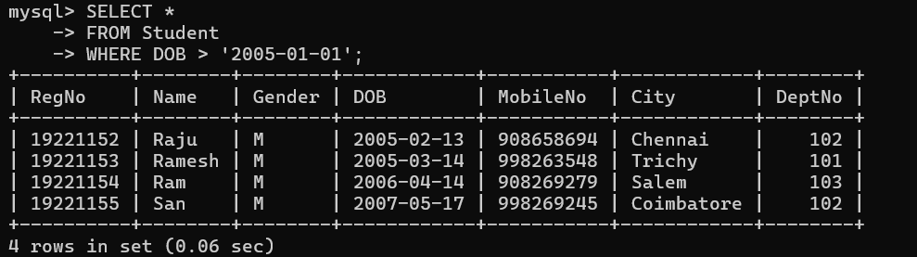

Q8 .Optimize a set of inefficient SQL queries by restructuring
them using joins, indexing concepts, or views, and
evaluate performance improvements.
Bloom’s Level: BL5 – Evaluate
ANS: Query 1: Inefficient Query (Using Subquery)
Problem: Display the names of students who belong to the CSE department.
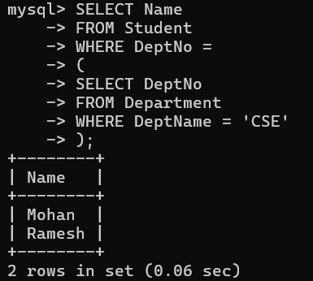
Query 2: Optimization Using View
Create a view to simplify repeated queries.
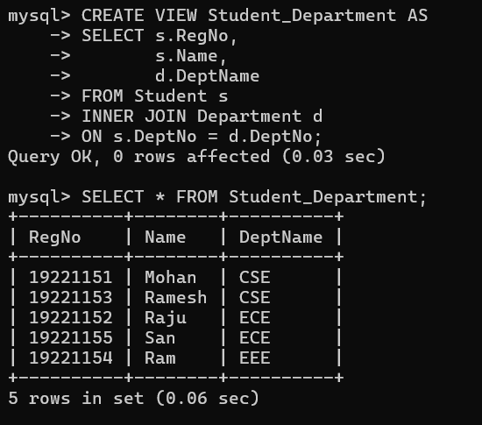

Q9. Develop a complex SQL query involving grouping, aggregation, and nested queries to solve a real-world problem
Scenario
A Student Management System stores student records. The administrator wants to know the number of students in each city and identify cities that have more than one student.
Query 1: Grouping and Aggregation
Display the number of students in each city.
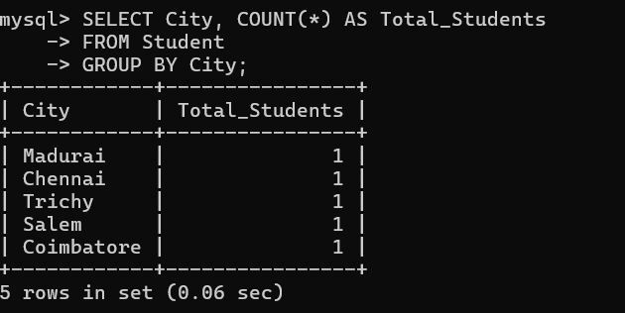

Q10. Given multiple relations, analyze the query requirements and decide whether to use Views, JOINs, or Subqueries, justifying your choice with reasoning.
Bloom's Level: BL5 – Evaluate
Relations
STUDENT(RegNo, Name, Gender, DeptNo, City)
DEPARTMENT(DeptNo, DeptName, HOD)
1. Using JOIN
Query
Display the student name along with the department name.
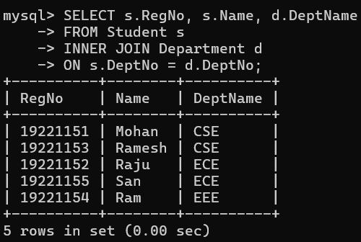
Reason
- JOIN is used because data is required from both Student and Department tables.
- It is faster and more efficient for retrieving related data from multiple tables.

- 2. Using SUBQUERY
- Query
- Display the names of students who belong to the CSE department.
